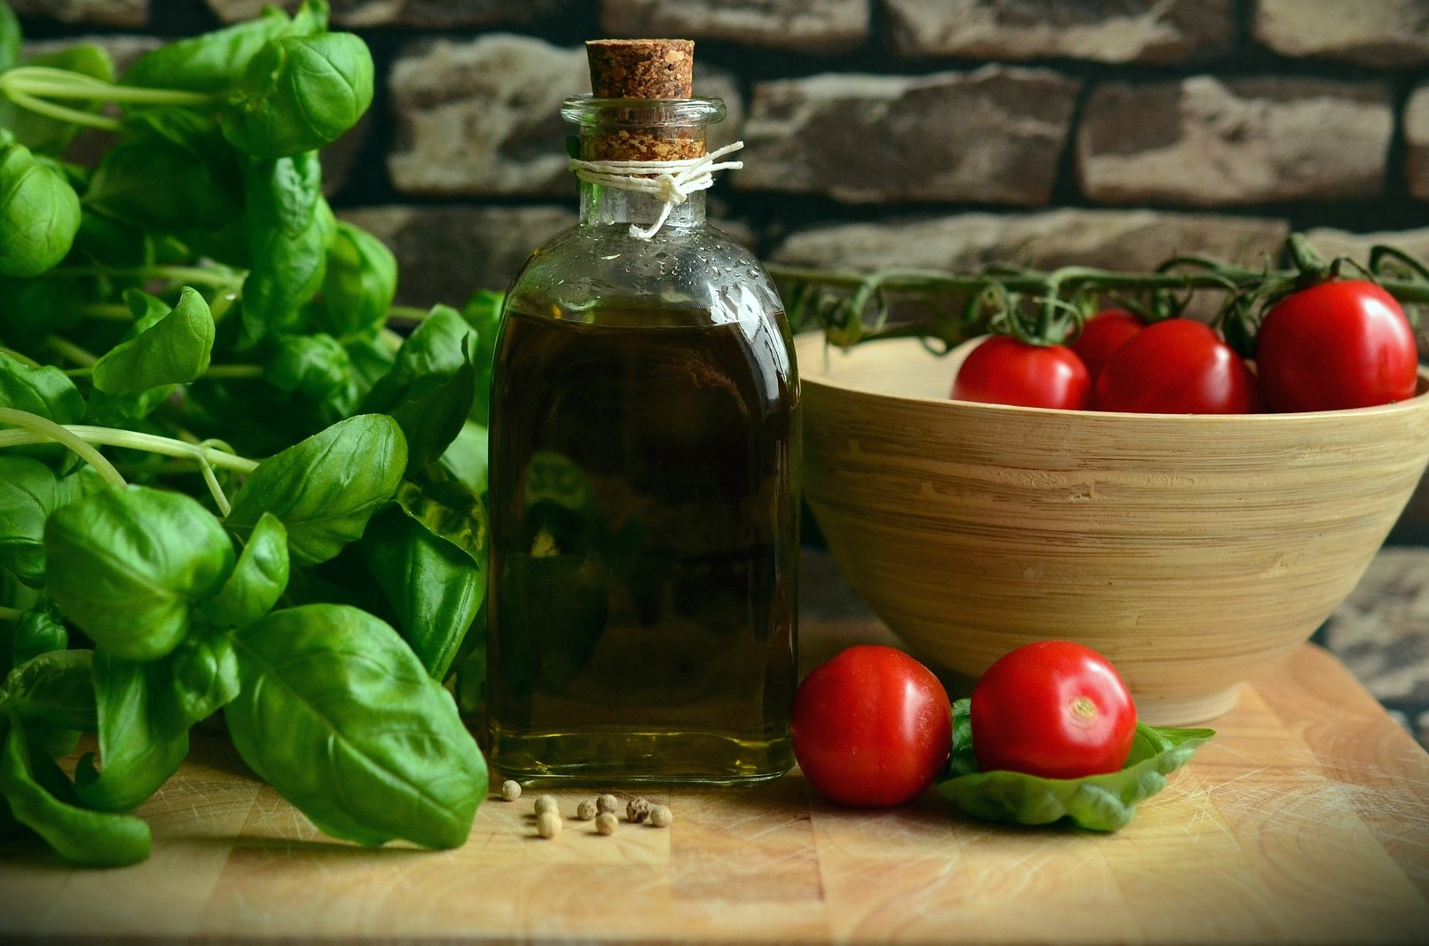

|  |
| --- |
| 4 Seasons Brasserie App User Guide |
|  |
| June 9  BSc Computer and System Development  Authored by: Amy Falconer Student ID: 126185 |



Contents

Product Introduction 3

User Interface 4

Register and Login 4

Onboarding 5

Navigation 6

App Features 7

Reserve a table with us 7

Availability and booking 7

Confirmation of Reservation 8

Cancellations or reservation updates 8

Online Booking 8

Available Menus 8

Your Cart 9

Checking out and payment 9

Cancellations or Changes 11

Events and Promotions 11

Privacy Policy 12

Information Collection and Use 12

Log Data 12

Cookies 13

Service Providers 13

Security 13

Links to other sites 14

Children’s Privacy 14

Changes with policy 14

Contact Us 14

# Product Introduction

4 Seasons Brasserie (4SB) is a locally owned Eastbourne Restaurant situated in the harbor focusing on high quality customer service and a warm atmosphere. We hold 60 tables suitable for all ages: cater for parties; hold live music events; and provide exquisite food. Our app intends to bring that experience to you.

Figure 1 - 4SB Android App Icon

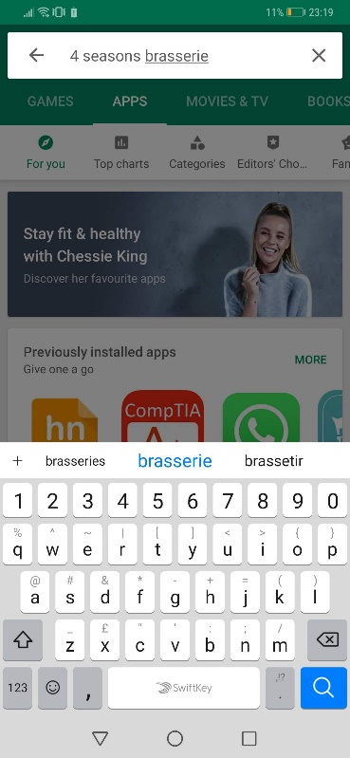From this platform, you’ll be at the front line for event updates whilst having the ability to book your table from your phone. Not only can you reserve tables and view events, this app allows us to bring the 4 Seasons experience directly to your door. Log in to your account, browse our menu and add items into your basket to order your 4SB takeaway. Download via the GooglePlay Store or via our website www.4Seasonsbrasserie.com. Look for our app icon shown in figure 1. Find us located in the app store by searching us show in figure 2 or download from our website in figure 3.

Figure 2 - GooglePlay Store

Search for 4SB

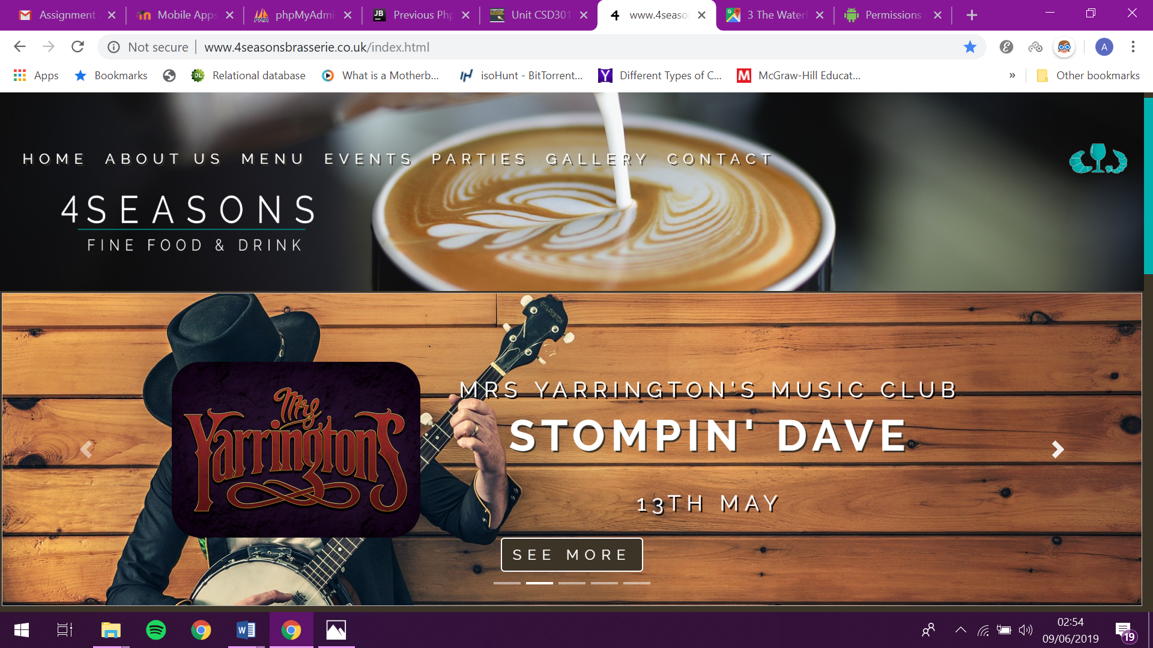

Figure 3 - 4 Seasons Website

# User Interface

## Register and Login

Upon successful download of the app, you will be asked for the following permissions:

* Access to the internet;
* Read/Write access to internal SD storage;
* Access to your contacts;
* Access to your location.

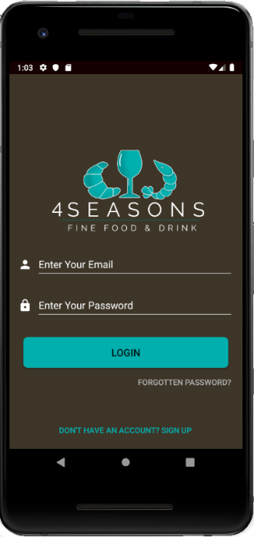Once accepted, the application will install and the 4SB icon will appear on your home screen. Click the icon and our splash screen (seen in figure 4) will appear and after a few seconds, you’ll be relocated to our login page (figure 5). If this is your first time with us, you’ll need to register. Don’t worry, it won’t take two minutes. Just click on the ‘Don’t have an account? Sign Up’ button at the bottom of the screen. Follow the hint text in each text box to help you when entering the information required to register. The details we require for registration are:

Figure 4 - 4SB Splash Screen

* A unique email address;
* A password consisting of at least 8 characters, 1 uppercase and 1 lowercase and 1 special character or number;
* Your date of birth (we’re not being cheeky, promise! We sell alcohol through this app and need to check for legal reasons);
* Your first and last name.

Click Register and you’re all set!

Figure 5 - Log in page

## Onboarding

Once you’ve registered, you’ll go through our onboarding process. Just a quick few screens to help you get accustomed with the app. See figure 6 as a reference. All you need to do is click the next and previous buttons (or swipe) to flick through these to reach your home screen.

Figure 6 - Onboarding screens

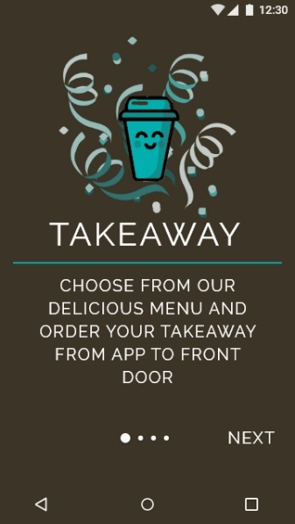 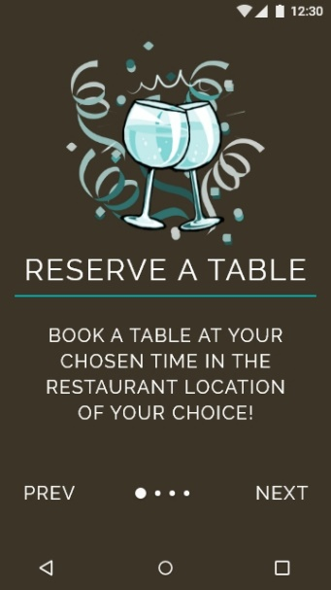 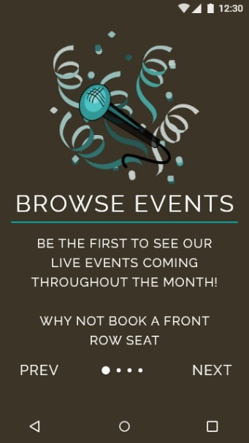 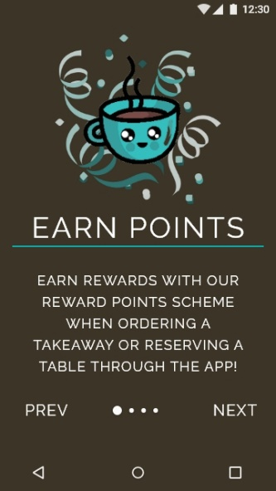

## Navigation

We’ve tried to keep our navigation as close to your device’s navigation as possible to keep things simple and allow you to book that table asap. You’ll recognize the 3 lines in the top left of the navigation bar, it houses all your needs. Click this and the side navigation menu will slide out shown in figure 7, allowing you access to your reservations, orders, our events, promotions, discounts and more. Click the icon or anywhere else on the screen to close the side menu.

Figure 7 - Navigation Screens

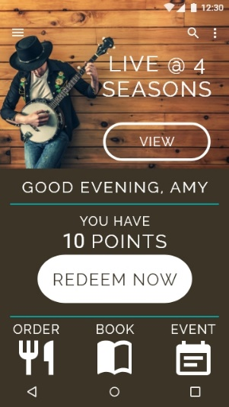 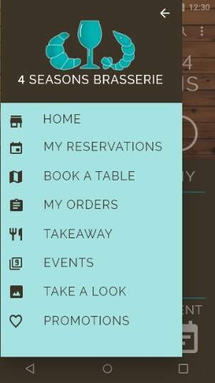 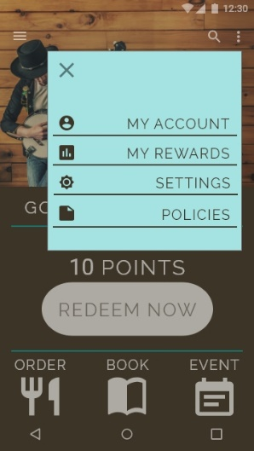 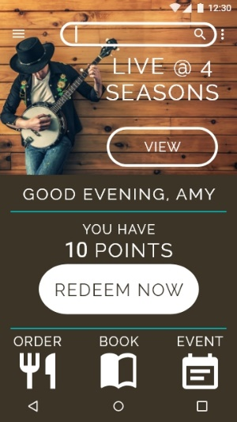

To access your profile settings, our policies and the general app settings, click the top right icon of 3 dots. This allows a menu to drop down with links to these features, click the close icon top left or click elsewhere on the screen to close the settings tab. To search the app, click the magnify glass and type your search term and either press enter or click the icon to search.

# App Features

## Reserve a table with us

### Availability and booking

To check the availability of the table, click the quick link icon ‘BOOK’ on the home page and enter your desired criteria for your reservation. Once you decided on your time, click the search button to see available tables that match your criteria.

Figure 8 - Reservation screen

### Confirmation of Reservation

Once the table has been successfully reserved for you, you will receive a confirmation email to the email address registered with the app as well as being transferred to the confirmation page. Click the home button to leave this screen.

### Cancellations or reservation updates

To modify or cancel a reservation, click the side menu icon in the home screen and click my reservations. This will bring up a list of your current reservations, to which you can click the edit (pencil) or delete (trash bin) to fulfil your requirements. Upon successful completion, you will receive a confirmation email and be redirected to the confirmation page.

## Online Booking

### Available Menus

Through the app you will be able to order our delicious meals straight to your door. Click the order icon in the bottom right corner of the home screen to open our menus. Our menus are listed however only certain menus will be available at certain times, for example, you won’t be able to get our evening menu in the morning. See figure 9 for the screen examples.

Figure 9 - Takeaway Menu

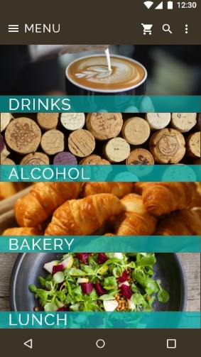 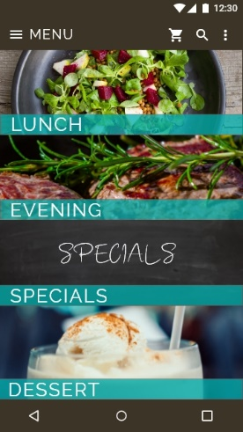 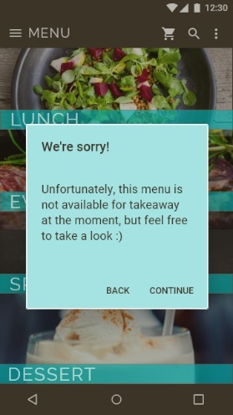

### Your Cart

Once you’ve found the item that takes your fancy, click the plus and minus icons to change the quantity you want for the item. Once decided, click the add to cart button.

Figure 10 - Add item to cart

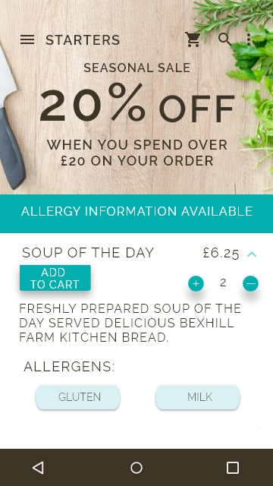 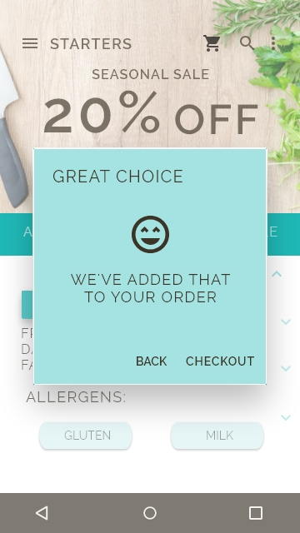

### Checking out and payment

To proceed to checkout, click the checkout button when you add an item or the cart icon in the navigation bar. Verify the summary of your order is correct and enter your details such as delivery address, delivery time, special requests and then click the proceed to payment. Enter your payment details, we provide secure payment transactions, and click pay. This process is shown in figure 11.

Figure 11 - Checkout Process

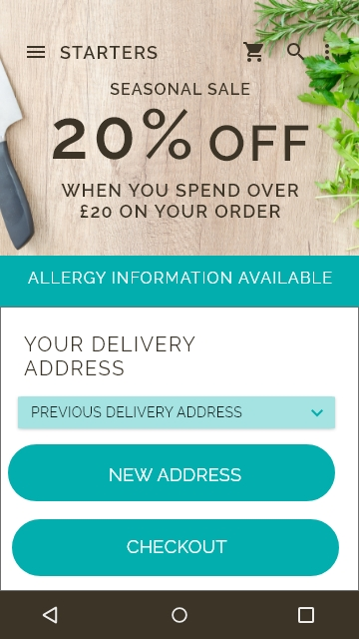 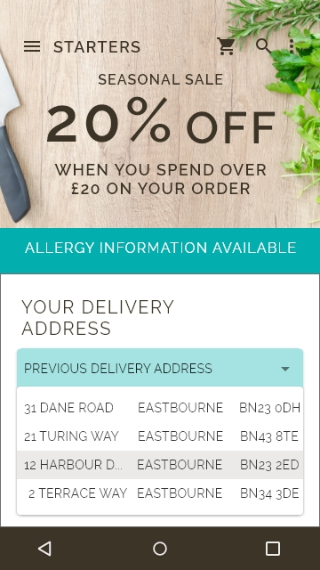 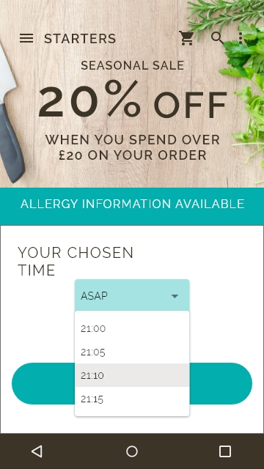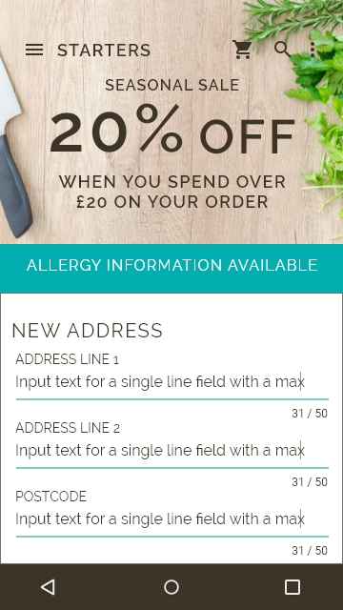 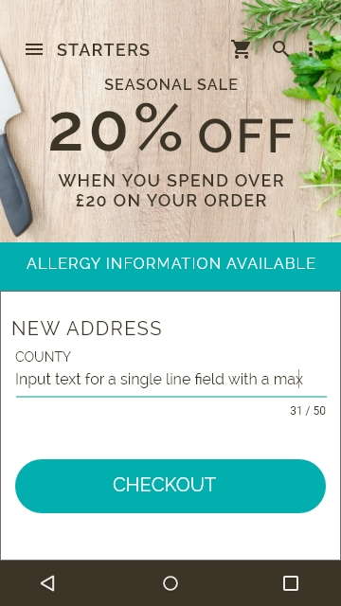 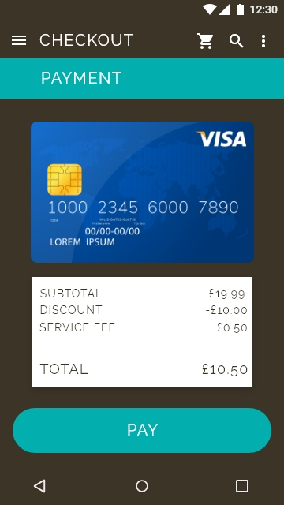

### Cancellations or Changes

Cancellations or changes to the order will require you to call the restaurant to process this.

## Events and Promotions

Be the first to hear about the latest events and promotions at 4 Seasons Brasserie. We will send you notifications of events you decide to follow and even better, why not book a table for that event. To give you the best of experience of app and restaurant, we regularly add promotions for booking a table for an event through the app. How does a free bottle of wine sound?

Figure 12 - Events

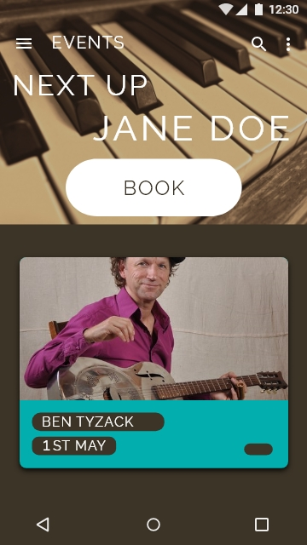 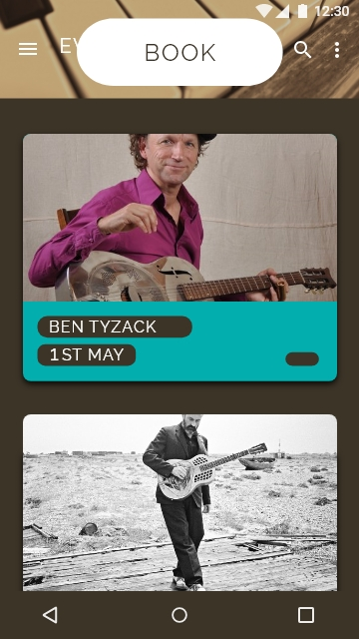 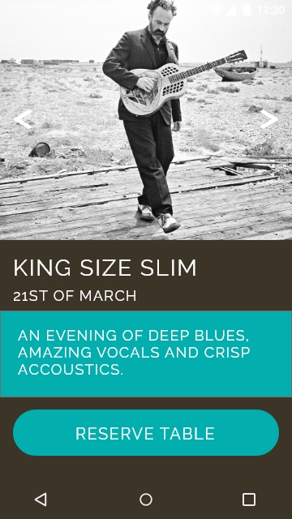

# Privacy Policy

Amy Falconer built the 4 Seasons Brasserie app as a Free app. This SERVICE is provided by at no cost and is intended for use as is.

This page is used to inform visitors regarding my policies with the collection, use, and disclosure of Personal Information if anyone decided to use my Service.

If you choose to use my Service, then you agree to the collection and use of information in relation to this policy. The Personal Information that I collect is used for providing and improving the Service. I will not use or share your information with anyone except as described in this Privacy Policy.

The terms used in this Privacy Policy have the same meanings as in our Terms and Conditions, which is accessible at 4 Seasons Brasserie unless otherwise defined in this Privacy Policy.

### ****Information Collection and Use****

For a better experience, while using our Service, I may require you to provide us with certain personally identifiable information, including but not limited to First Name, Last Name, Date of Birth, Transactions but not card details. The information that I request will be retained on your device and is not collected by me in any way.

The app does use third party services that may collect information used to identify you.

Link to privacy policy of third-party service providers used by the app

* Google Play Services

### Log Data

I want to inform you that whenever you use my Service, in a case of an error in the app I collect data and information (through third party products) on your phone called Log Data. This Log Data may include information such as your device Internet Protocol (“IP”) address, device name, operating system version, the configuration of the app when utilizing my Service, the time and date of your use of the Service, and other statistics.

### Cookies

Cookies are files with a small amount of data that are commonly used as anonymous unique identifiers. These are sent to your browser from the websites that you visit and are stored on your device's internal memory.

This Service does not use these “cookies” explicitly. However, the app may use third party code and libraries that use “cookies” to collect information and improve their services. You have the option to either accept or refuse these cookies and know when a cookie is being sent to your device. If you choose to refuse our cookies, you may not be able to use some portions of this Service.

### Service Providers

I may employ third-party companies and individuals due to the following reasons:

* To facilitate our Service;
* To provide the Service on our behalf;
* To perform Service-related services; or
* To assist us in analyzing how our Service is used.

I want to inform users of this Service that these third parties have access to your Personal Information. The reason is to perform the tasks assigned to them on our behalf. However, they are obligated not to disclose or use the information for any other purpose.

### ****Security****

I value your trust in providing us your Personal Information, thus we are striving to use commercially acceptable means of protecting it. But remember that no method of transmission over the internet, or method of electronic storage is 100% secure and reliable, and I cannot guarantee its absolute security.

### ****Links to other sites****

This Service may contain links to other sites. If you click on a third-party link, you will be directed to that site. Note that these external sites are not operated by me. Therefore, I strongly advise you to review the Privacy Policy of these websites. I have no control over and assume no responsibility for the content, privacy policies, or practices of any third-party sites or services.

### Children’s Privacy

These Services do not address anyone under the age of 13. I do not knowingly collect personally identifiable information from children under 13. In the case I discover that a child under 13 has provided me with personal information, I immediately delete this from our servers. If you are a parent or guardian and you are aware that your child has provided us with personal information, please contact me so that I will be able to do necessary actions.

### Changes with policy

I may update our Privacy Policy from time to time. Thus, you are advised to review this page periodically for any changes. I will notify you of any changes by posting the new Privacy Policy on this page. These changes are effective immediately after they are posted on this page.

### ****Contact Us****

If you have any questions or suggestions about my Privacy Policy, do not hesitate to contact me at 4 Seasons Brasserie.